**HTML Assignment:**

1.

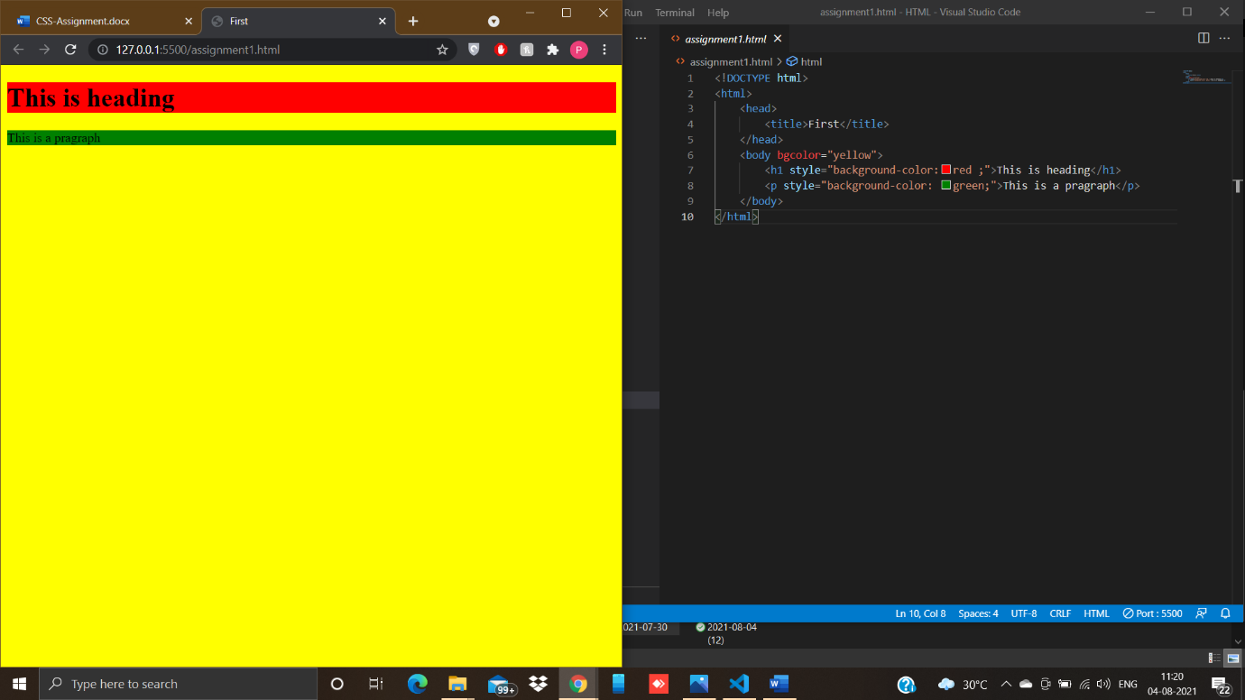

2.

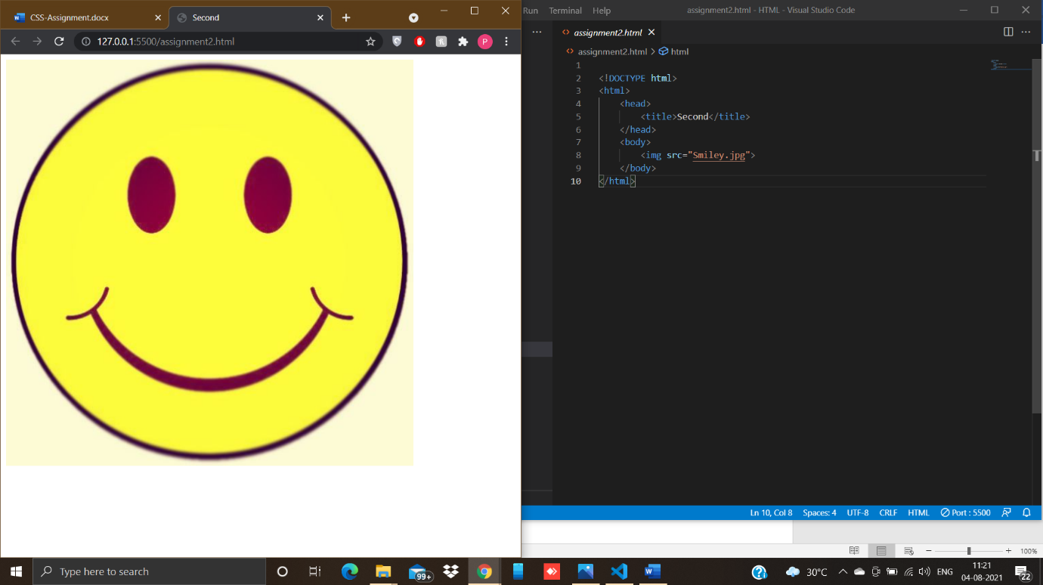

3.

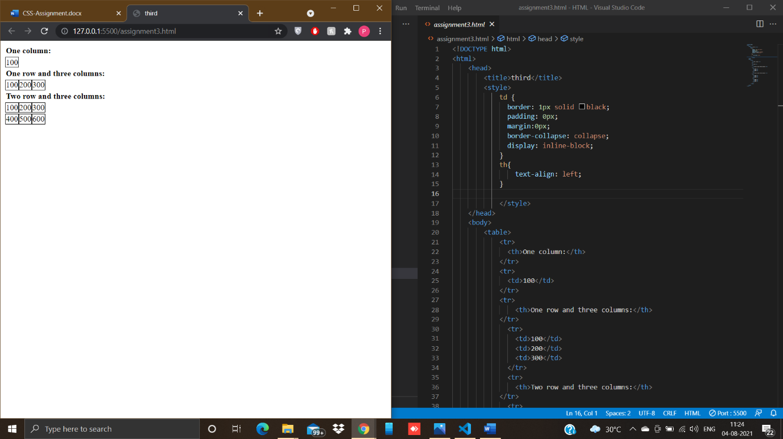

<tr>

                <td>100</td>

                <td>200</td>

                <td>300</td>

              </tr>

              <tr>

                <td>400</td>

                <td>500</td>

                <td>600</td>

              </tr>

          </table>

    </body>

</html>

4.

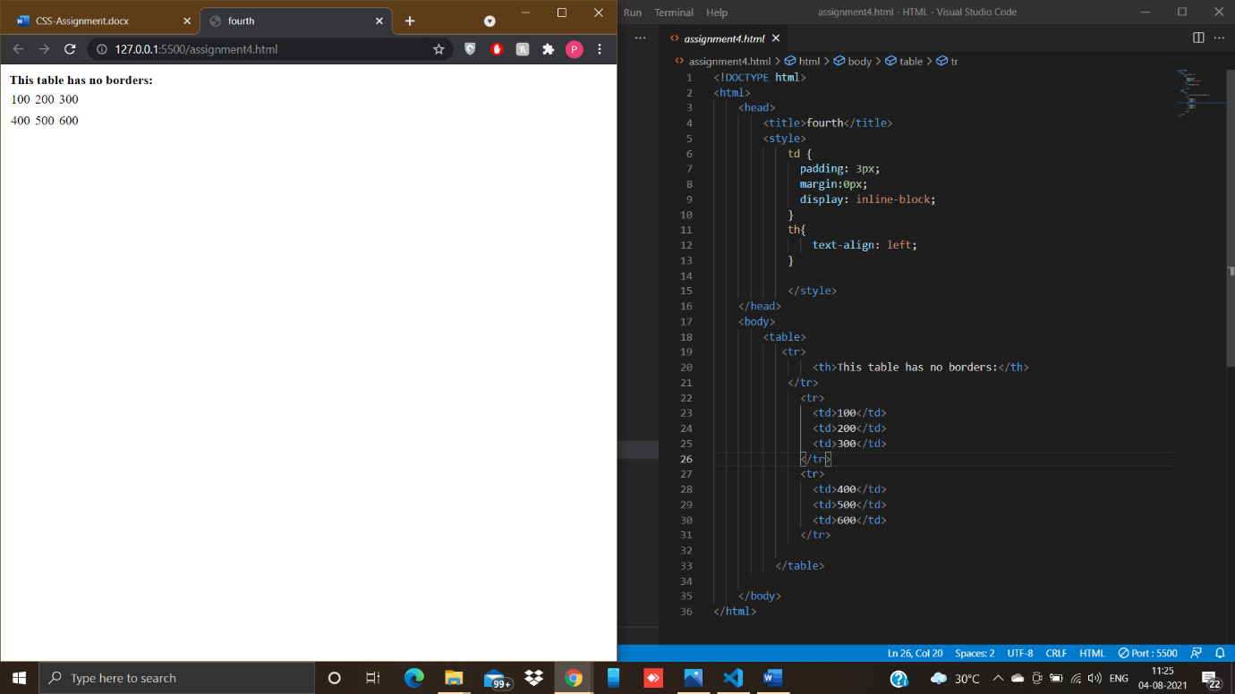

5.

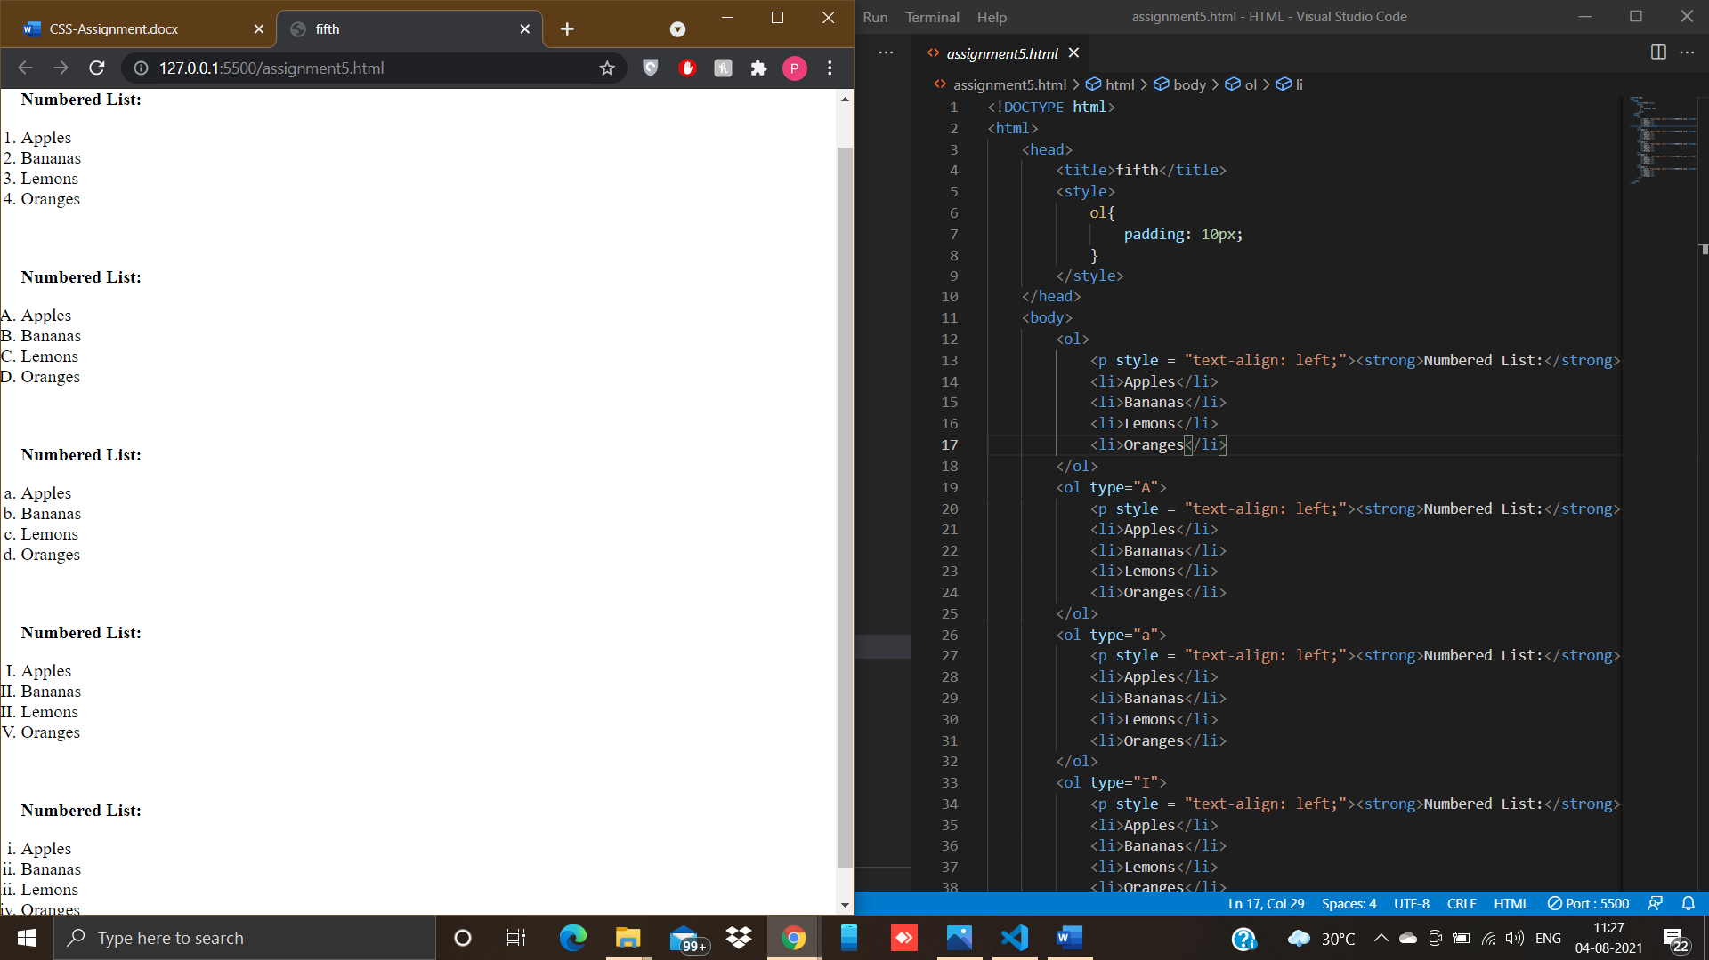

 <li>Oranges</li>

        </ol>

        <ol type="i">

            <p style = "text-align: left;"><strong>Numbered List:</strong></p>

            <li>Apples</li>

            <li>Bananas</li>

            <li>Lemons</li>

            <li>Oranges</li>

        </ol>

    </body>

</html>

6.

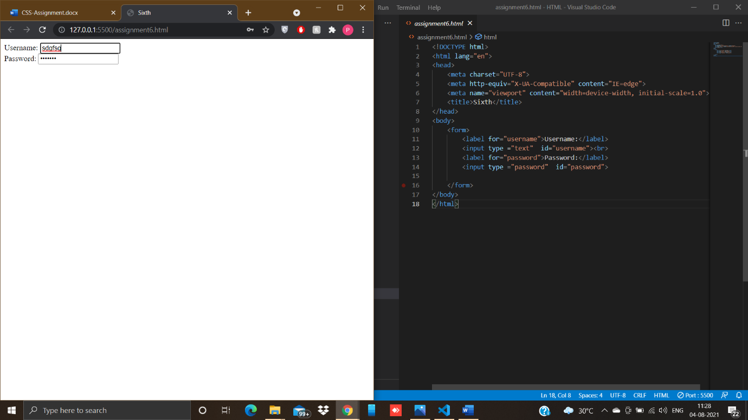

7.

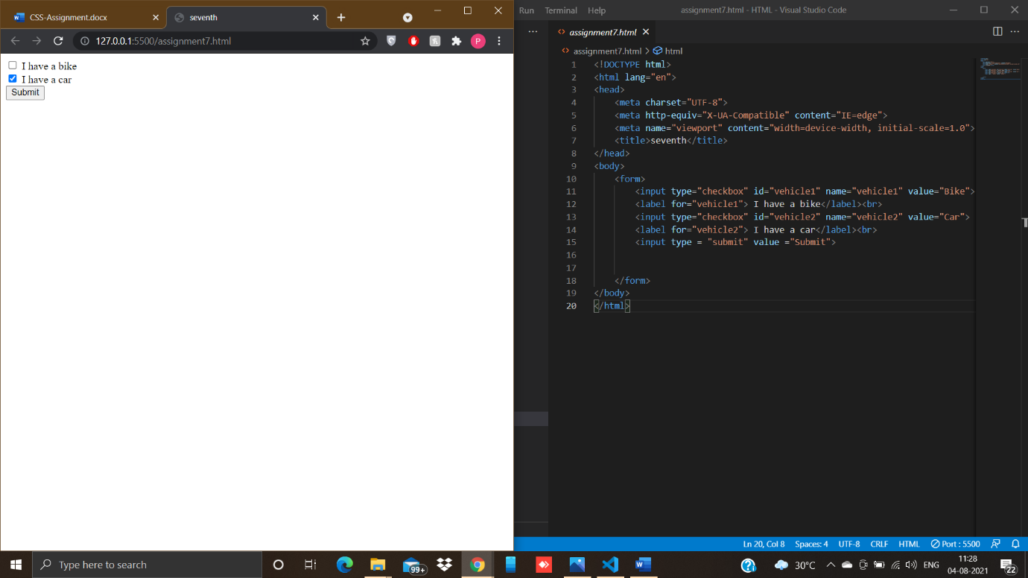

8.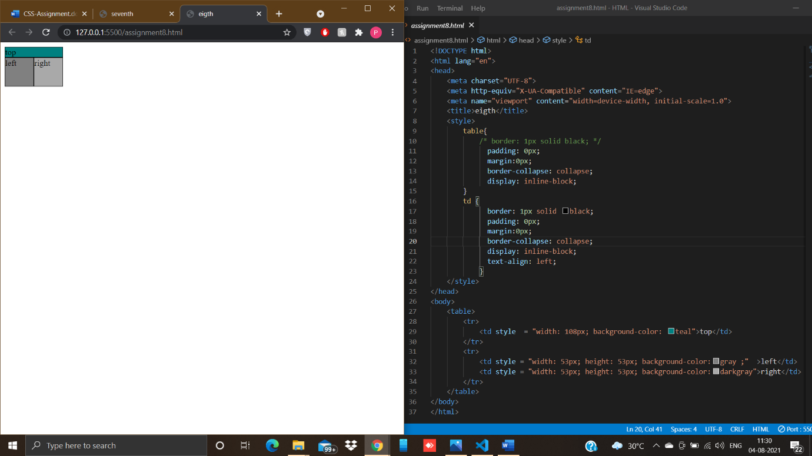

9.

